VIETNAM INTERNATIONAL UNIVERSITY – HO CHI MINH CITY

INTERNATIONAL UNIVERSITY

**WEB APPLICATION DEVELOPMENT PROJECT**

**E-commerce**

By

Nguyễn Đăng Bảo - Student ID: ITITIU20164

Huỳnh Ngọc Hoài Ân - Student ID: ITITIU20152

Nguyễn Cần - Student ID: ITITIU20171

Advisor: Dr. Nguyen Van Sinh

A report submitted to the School of Computer Science and Engineering

in partial fulfillment of the requirements for the Final Project

in Web Application Development course - Spring 2024

Ho Chi Minh city, Vietnam, 2024

**TABLE OF CONTENTS**

**I. INTRODUCTION**

**II. SYSTEM DESIGN**

**III. IMPLEMENTATION**

**III.1. User’s account management functions**

**III.1.1. Login to the store**

**III.1.2. Register a new account**

**III.1.3. Display user’s profile**

**III.1.4. Retrieve the password**

**III.2. Product viewing functions**

**III.2.1. View a category of products**

**III.2.2. View a specified product**

**III.2.3. Search product by name/function**

**III.2.4. Search product by price**

**III.3. Transaction functions**

**III.3.1. Add product to shopping cart**

**III.3.2. Remove product from shopping cart**

**III.3.3. Add product to wish list**

**III.3.4. Remove product from wish list**

**III.3.5. Checkout your orders from the shop**

**III.4. Store management functions**

**III.4.1. View options**

**III.4.2. View Users**

**III.4.3. View Categories**

**III.4.4. View Product List**

**III.4.5. View Infos**

**III.4.6. Order status**

**III.4.7. Blogs Managing**

**III.4.8. Comments managing**

**III.4.9. Order errors**

**IV. DISCUSSION AND CONCLUSION**

**V. REFERENCES**

**I. INTRODUCTION**

We offer an online shop system in response to the customer company's desire to streamline the ordering and purchasing process through the use of web platforms. Our method makes it simpler, quicker, and more convenient for customers to select and purchase furniture products.

In particular, our technology makes it easier for individuals to order and buy products from the comfort of their own homes by interacting with a web-based system through computer and mobile platforms. Specifically, in comparison to earlier iterations, our website offers a few additional features, such as the ability for customers to directly evaluate and comment on products in the product area or verify product availability.

e-commerce platform, a dynamic and user-friendly online shopping destination built using the latest in web development technologies: PHP, JavaScript, HTML, and CSS.

PHP, a powerful server-side scripting language, forms the backbone of our website. It handles all the server-side operations, including user authentication, database interactions, and secure transactions. With PHP, we've ensured that our website is not only robust and scalable but also capable of handling high traffic volumes seamlessly. JavaScript brings our website to life by adding interactivity and dynamic content. It powers essential features such as product searches, filtering options, and real-time updates, ensuring a smooth and engaging user experience. With JavaScript, we've incorporated advanced functionalities like AJAX for asynchronous data loading, providing a fast and responsive browsing experience.

**II. SYSTEM DESIGN**

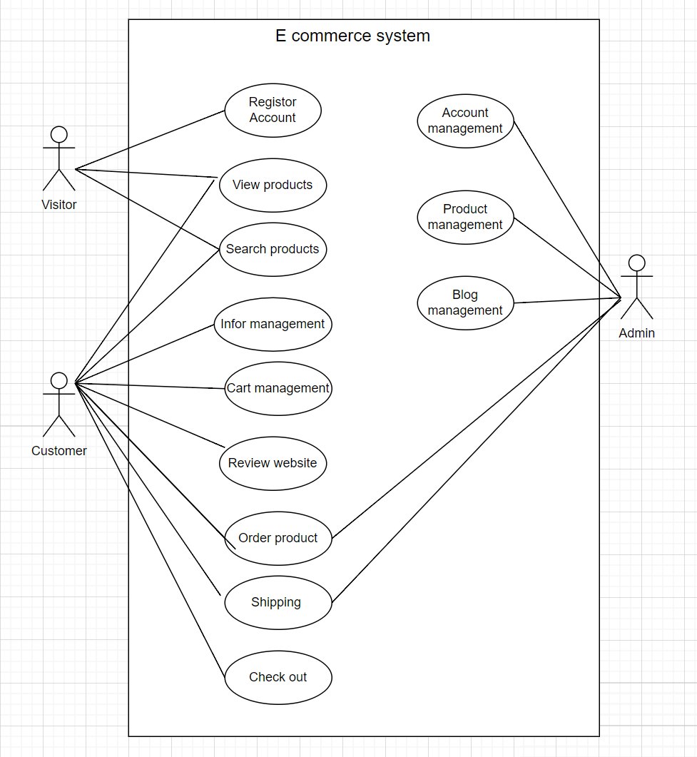

Use case diagram

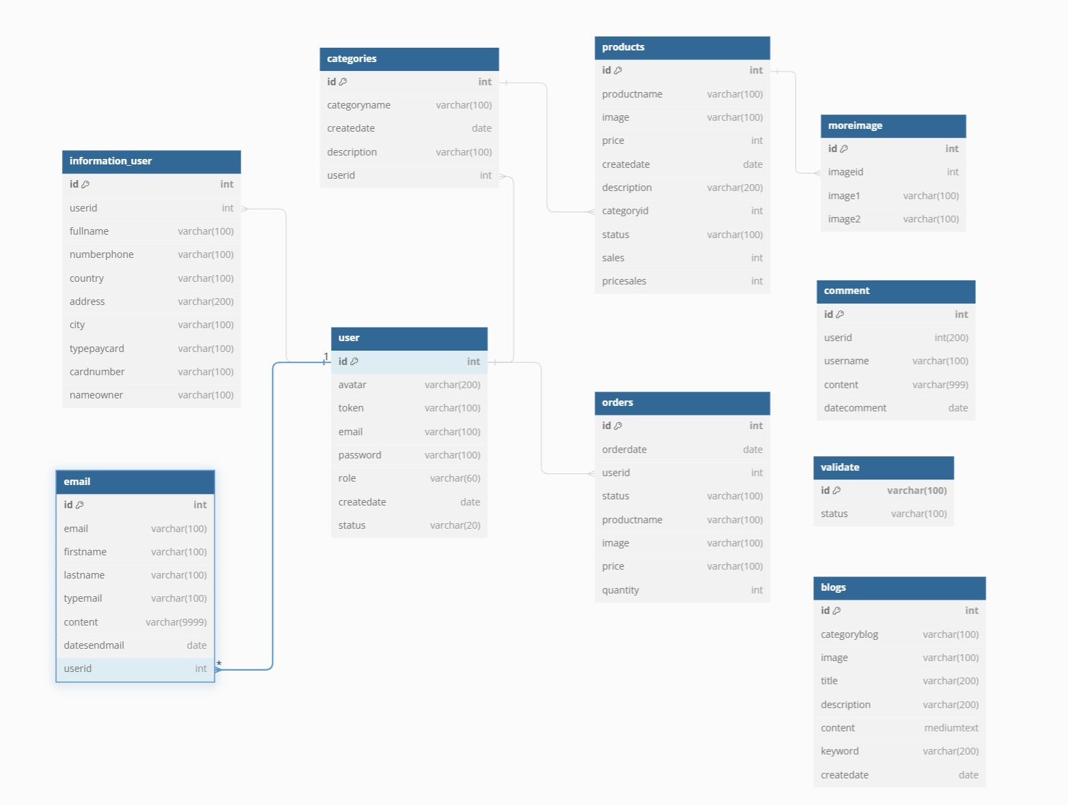

ER Diagram

**III. IMPLEMENTATION**

**III.1.User’s account management functions**

**III.1.1. Login to the store**

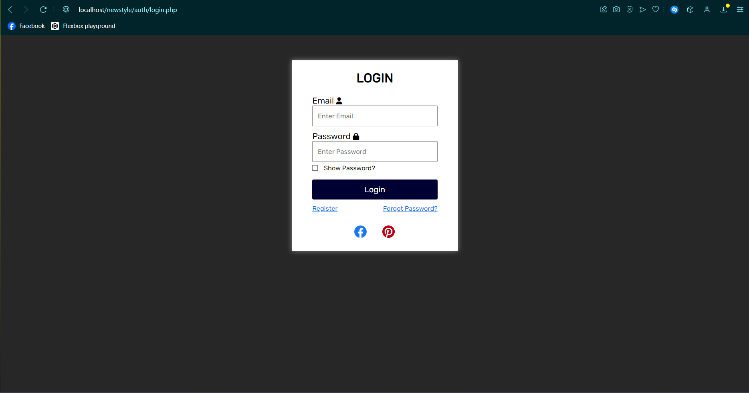

the login display

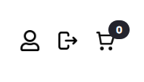

after login it will have icon to log out

**III.1.2. Register a new account**

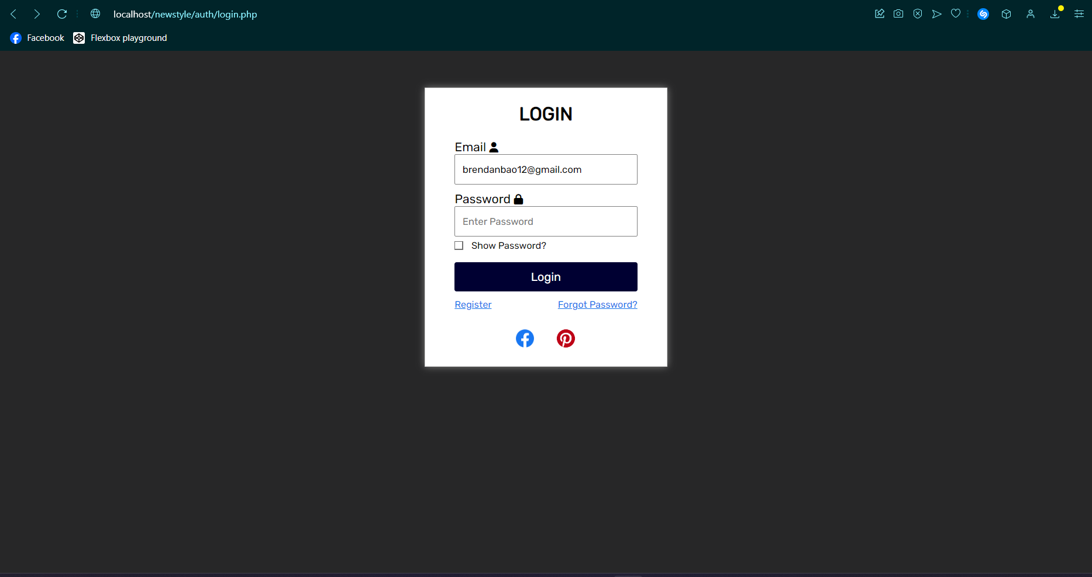

same page of login, now you want to create account, you click Register

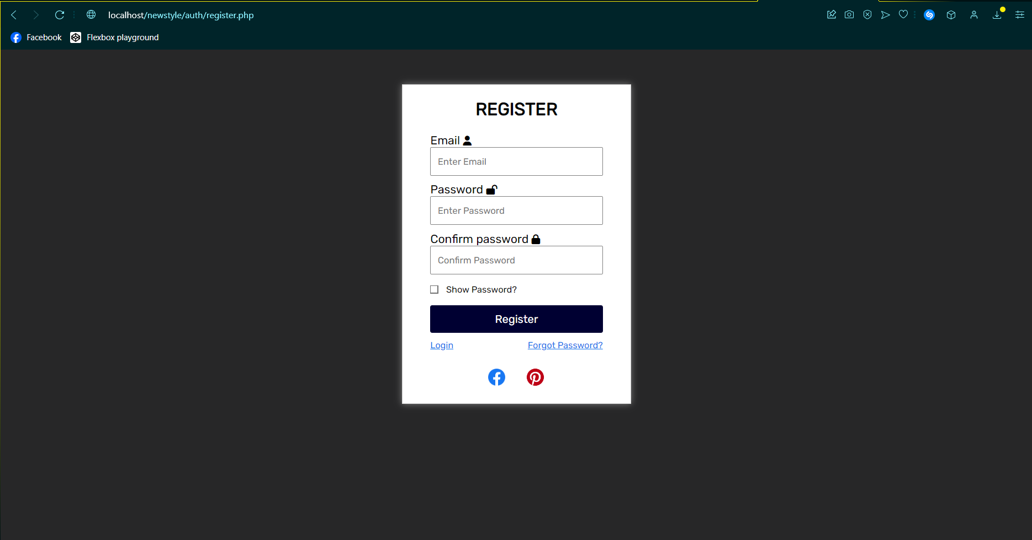

and now you type your email, create password and confirm

**III.1.3. Display user’s profile**

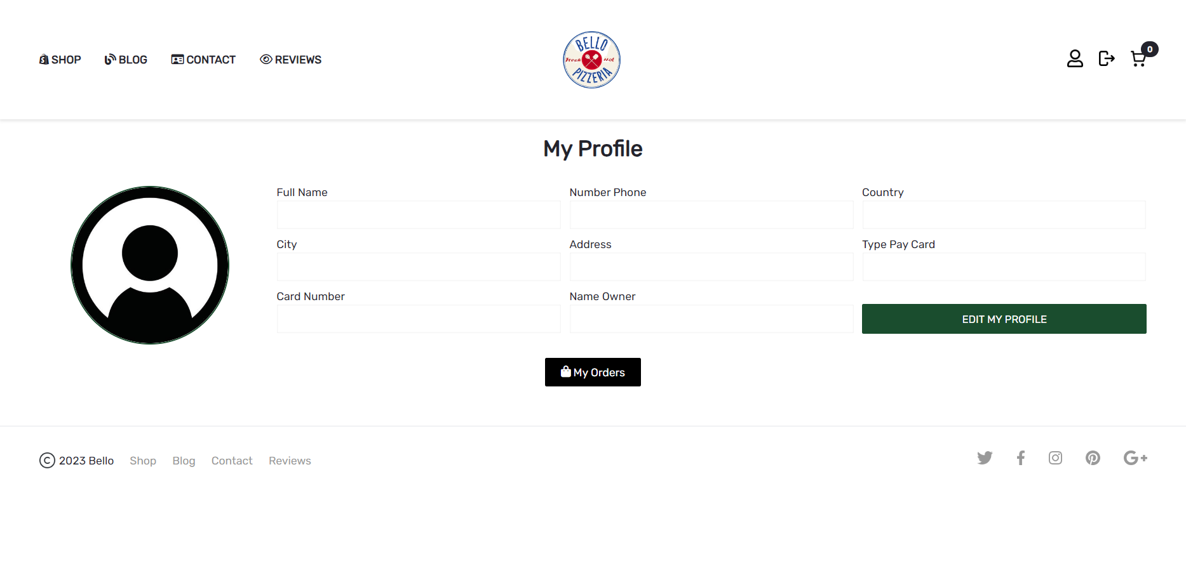

the user profile, you can edit it in EDIT MY PROFILE

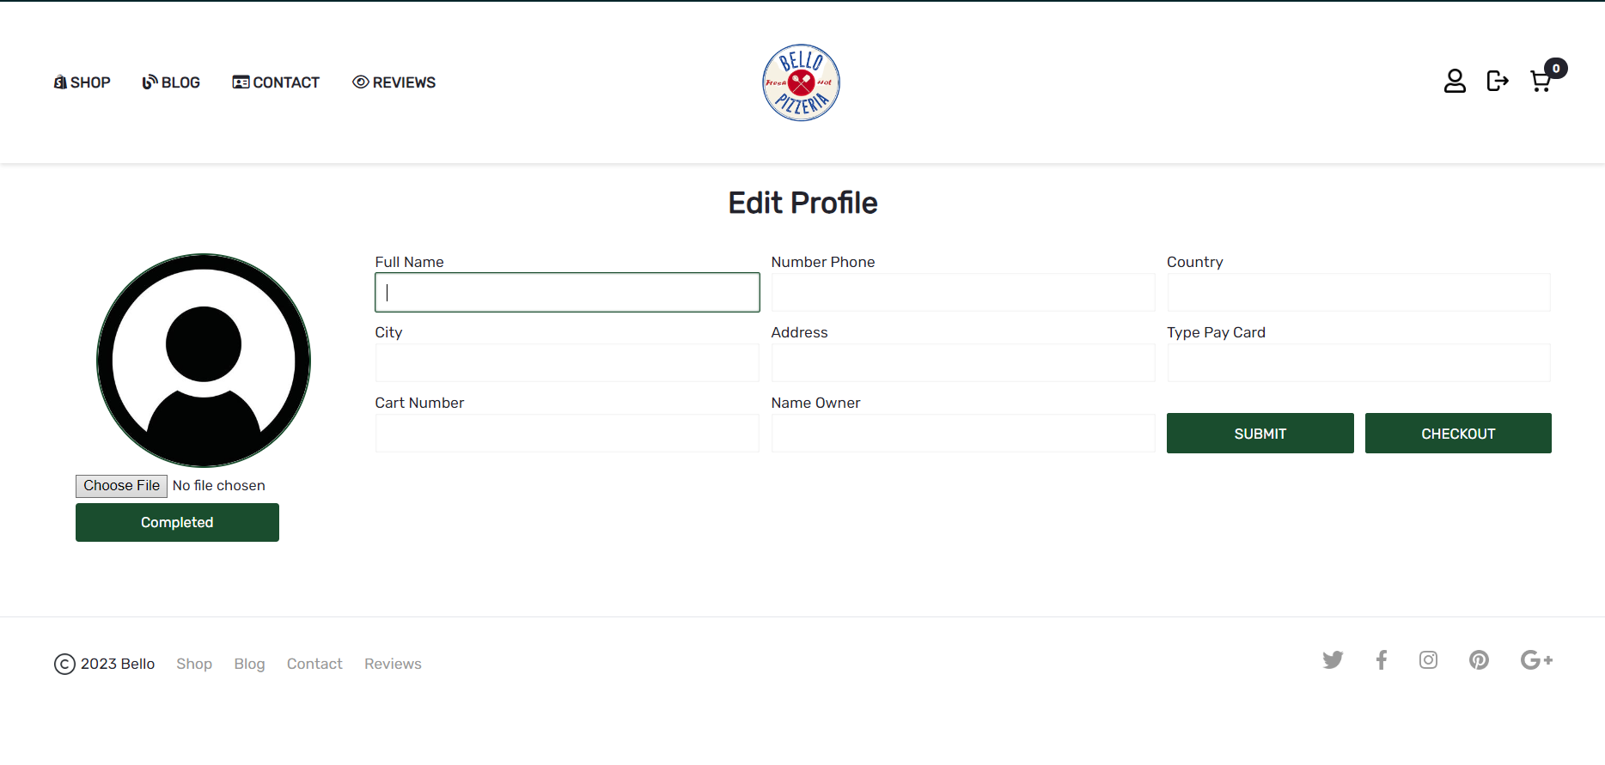

after i submit my info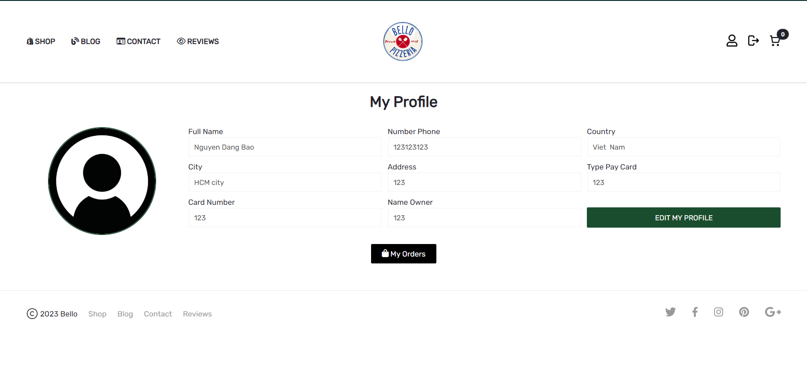

**III.1.4. Retrieve the password**



you can click forgot password here or in the login page

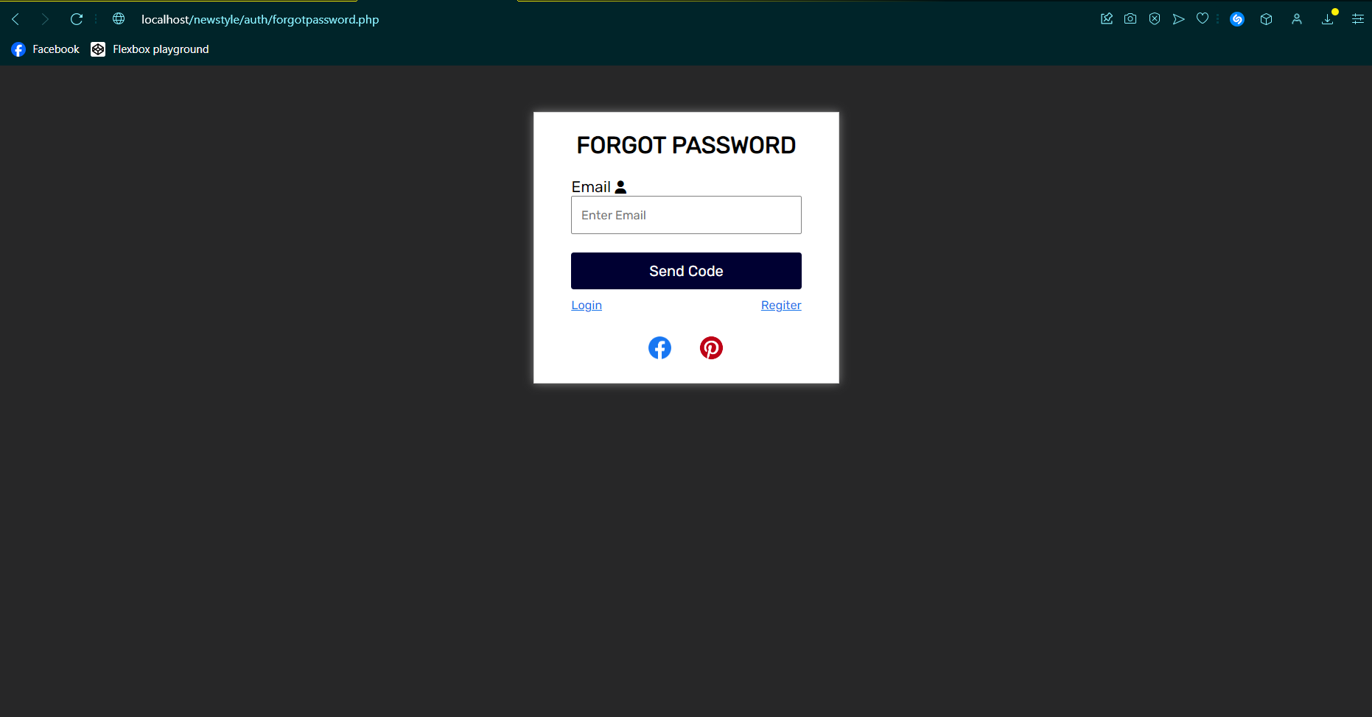you type your email here to receive code to reset password

**III.2 Product viewing functions**

**III.2.1. View a category of products**

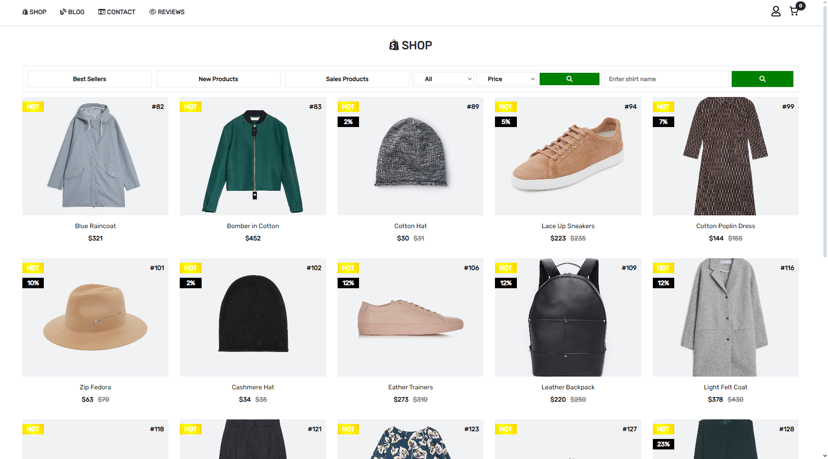

View the entire shop list of products

**III.2.2. View a specified product**

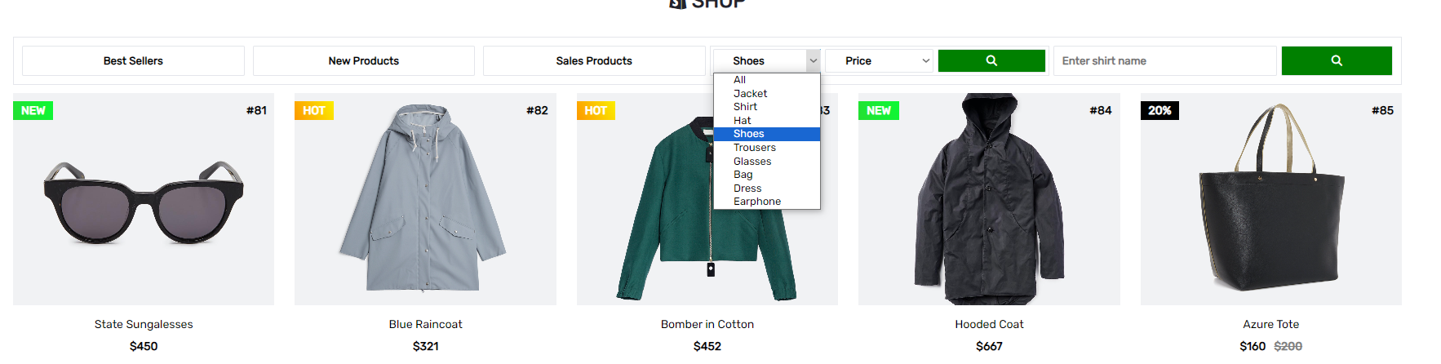

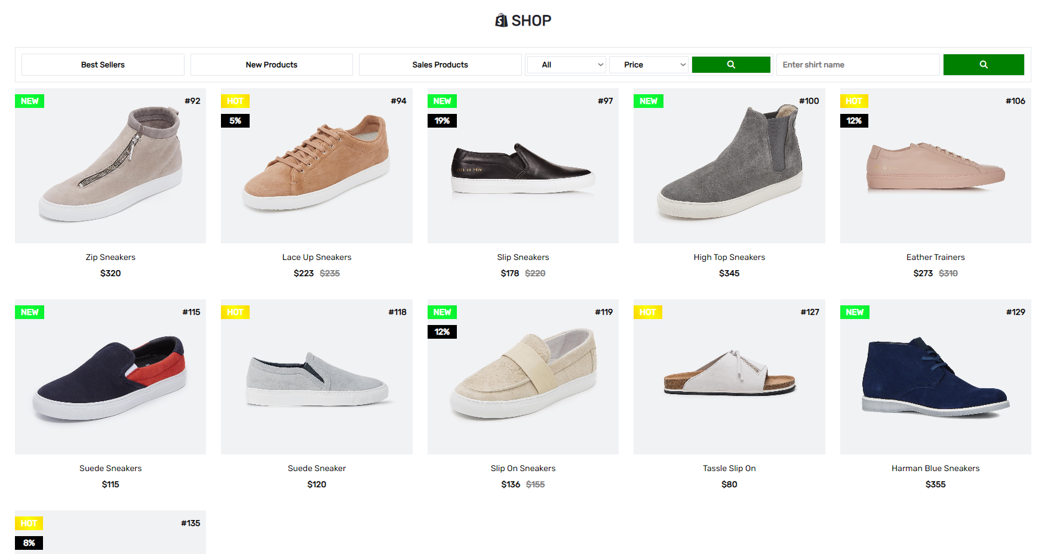

View the specified category by your desired

**III.2.3. Search product by name/function**

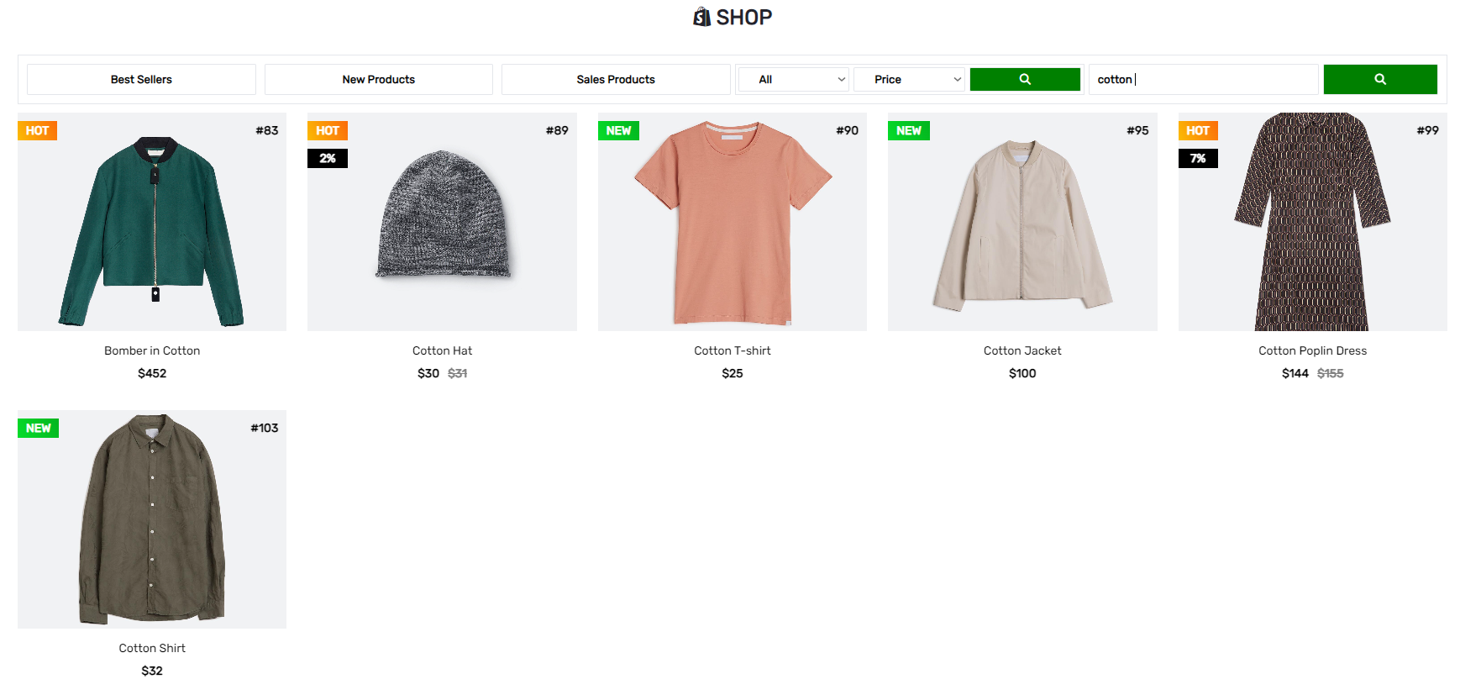

Search products by name to view that type of products only

**III.2.4. Search product by price**

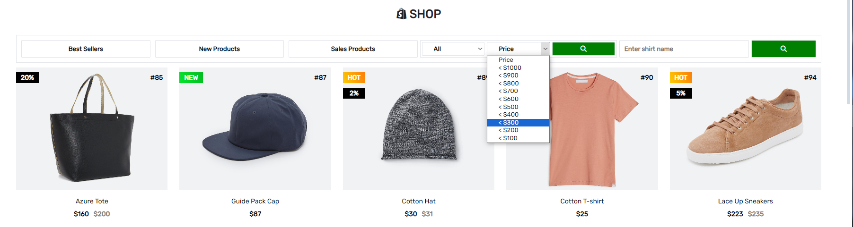

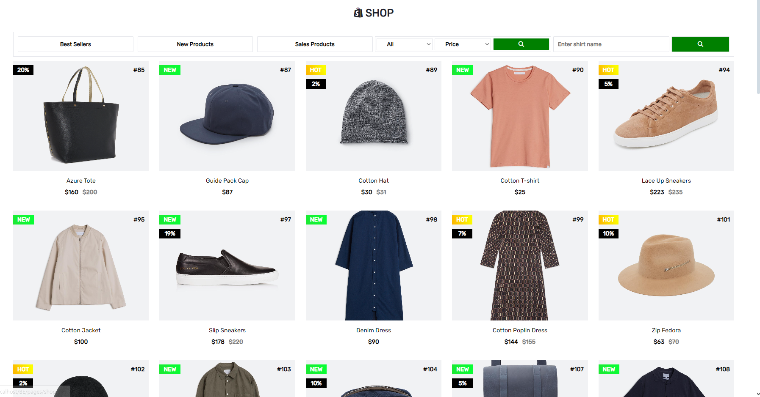

Search product by price accordingly

**III.3 Transaction functions**

**III.3.1. Add product to shopping cart**

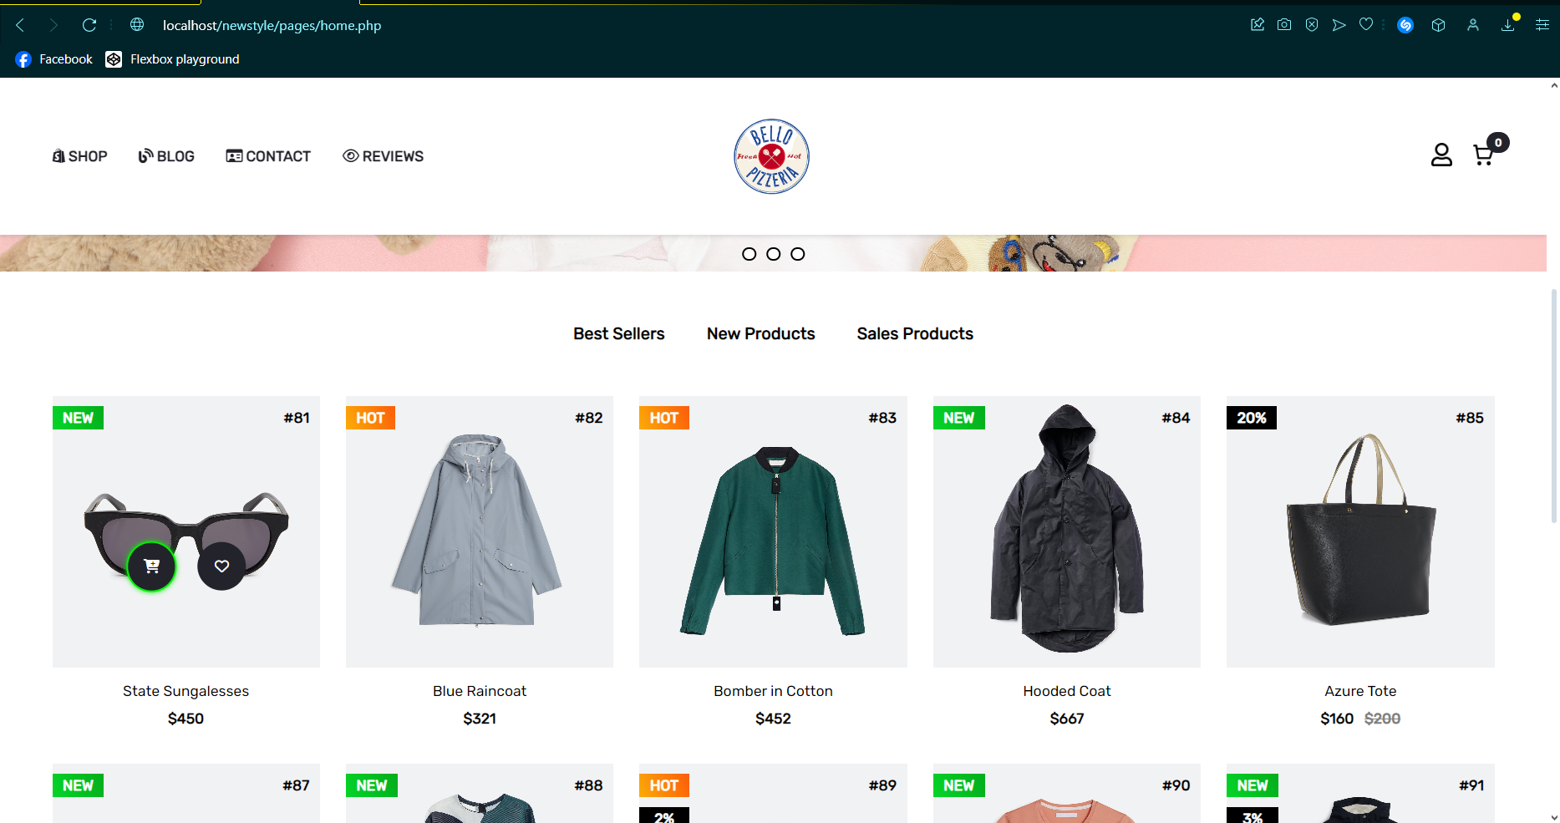Click the button on the left of the products you want to add to cart

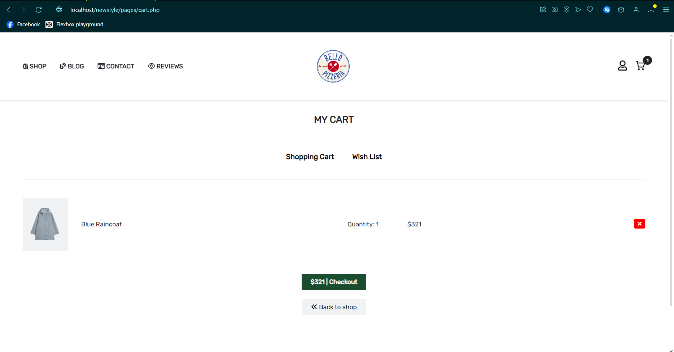

i choose the blue Raincoat and it appear in My cart

**III.3.2. Remove product from shopping cart**

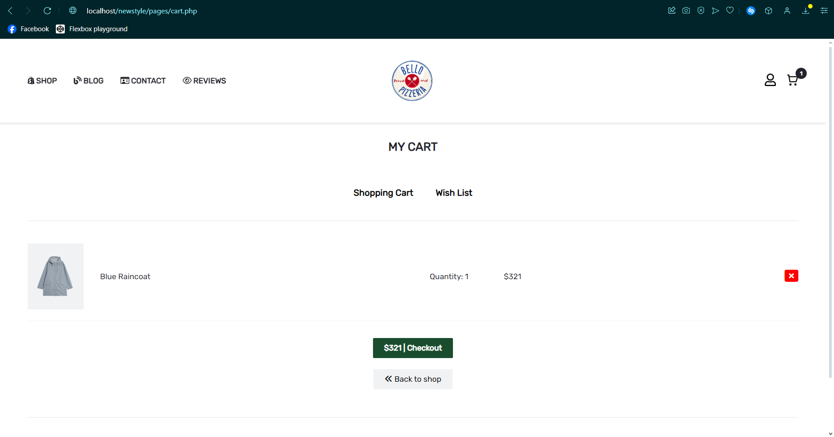

click the red button at the end of the products you want to remove to remove

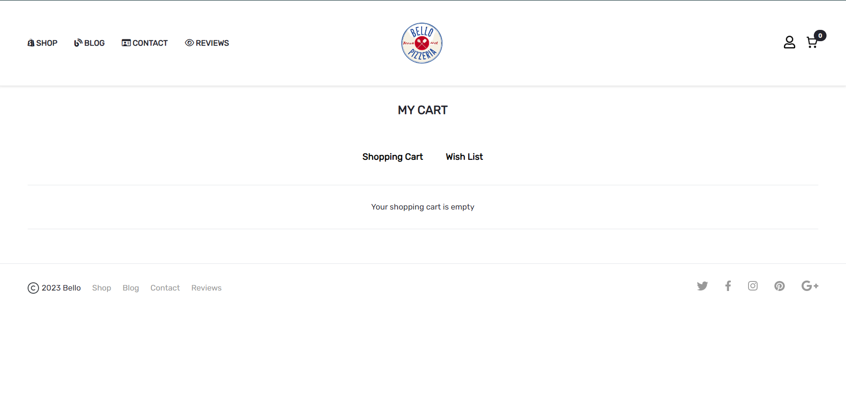

after remove it will show you that your cart is empty

**III.3.3. Add product to wish list**

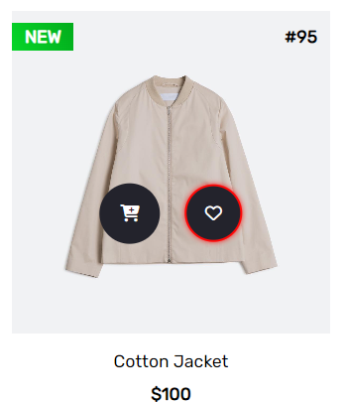

you click the button on the right to add items to wish list

**III.3.4. Remove product from wish list**



click the red button at the end of the product to remove like add to cart

**III.3.5. Checkout your orders from the shop**

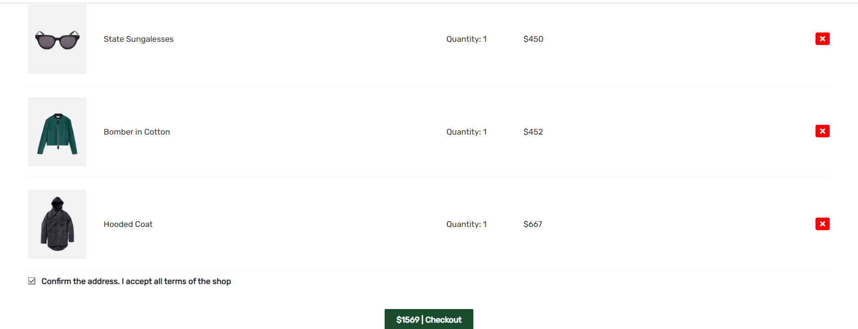

i add 3 products to the cart, if you want to check out you have to fill the check out information

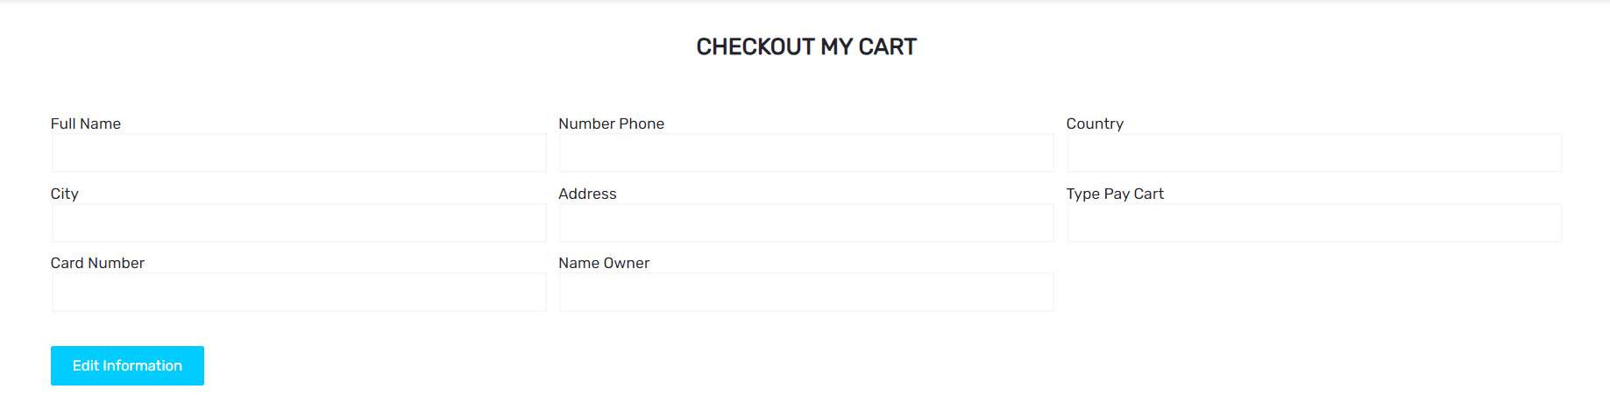

**III.4 Store management functions**

**III. 4.1. View options**

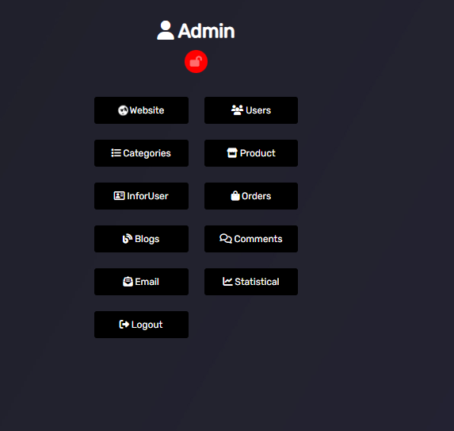

After admin login, he has different options to manage the page

**III. 4.2. View Users**

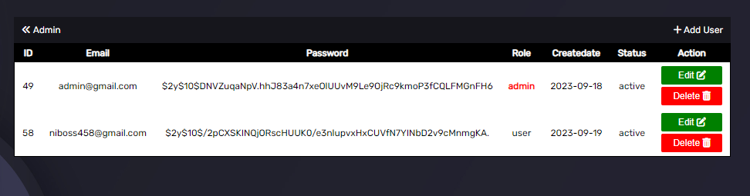

Admin can see which gmail are staff or user and he can edit them

**III.4.3. View Categories**

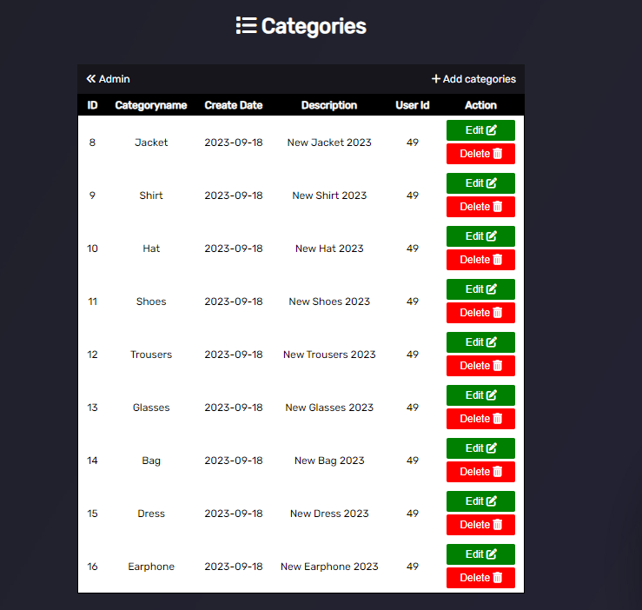

Admin can view, edit, add new or delete different categories based on the products

**III.4.4. View Product List**

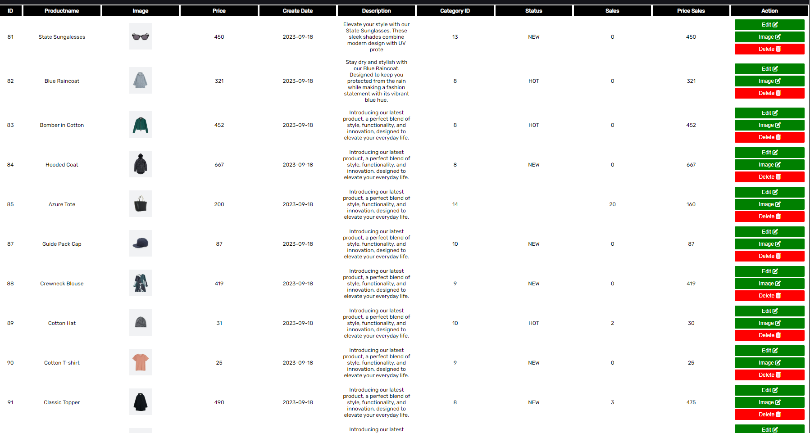

A list of product that Admin can see, add new, edit products description and images or delete them

**III.4.5. View Infos**

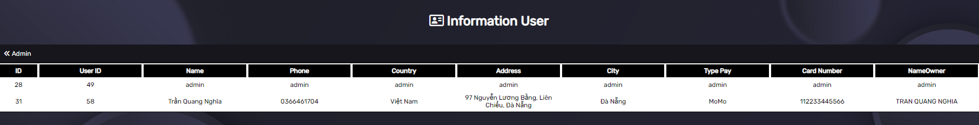

Admin can see the detail of information of users that has registered

**III.4.6. Order status**  
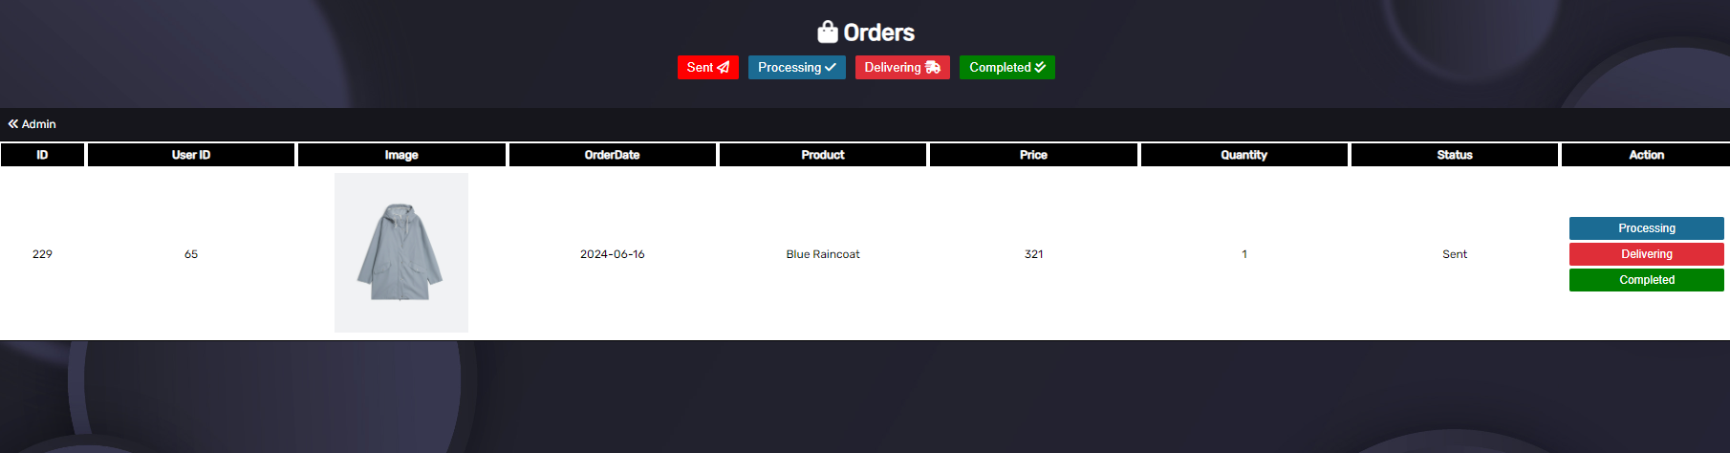

Admin can check for user the status of the product and send them the info of how and where is the product

**III.4.7. Blogs Managing**

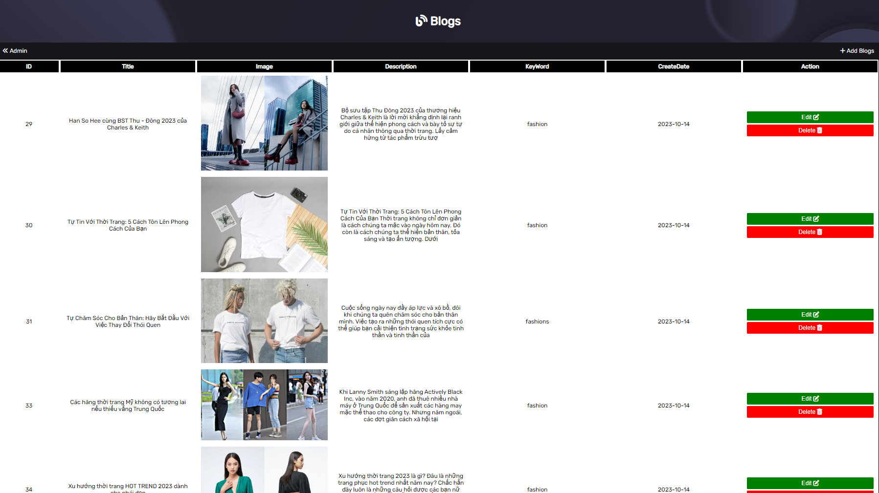

Admin can view, edit or delete blogs

**III.4.8. Comments managing**

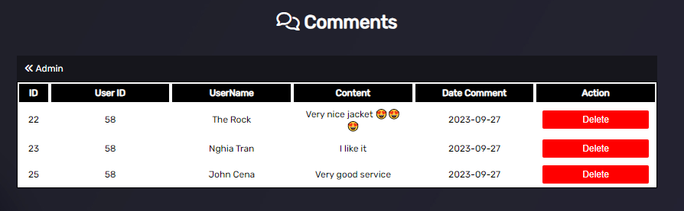

Admin can view and delete the comments that user made

**III.4.9. Order errors**

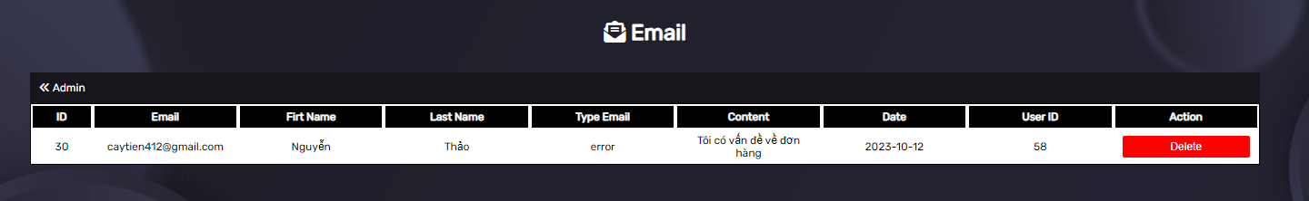

Admin is able to receive mails that users are having issues with

**IV. DISCUSSION AND CONCLUSION**

The Online Shopping store project provides us with a clearer understanding of the Web Application Development Process. After the current project is over, there are a few extensions we can keep developing and improving for later projects. First off, adding the feature of product recommendation—which presents customers with similar products to their purchases—must make the system more appealing and efficient for e-commerce. In this approach, the system makes it easier for customers to purchase more goods and increases the effectiveness of furniture store sales over time. Second, since this system is merely a local host computer demo.

Another thing to consider in this regard is that we learned a lot from both the present and earlier activities thanks to the Web Application Development Project. First and foremost, the ability to code and arrange

The project's source code has undergone significant improvement. This key greatly aids us in the long-term development and maintenance of the system, as well as in the future. Next, before writing the first line of code, the project teaches us how to analyze and determine the requirements of the system in the sketch version of implementation. Eventually, the members' teamwork and communication abilities have greatly improved as a result of operating in such a vast system.

**V. REFERENCES**

* **Web-page template**

http://themeforest.net/

* **HTML, CSS, JavaScript techniques**

[www.w3schools.com](http://www.w3schools.com)

* **Database Management System (DBMS)**

https://www.apachefriends.org